- Load the 'Mall Customers' dataset (or any small customer dataset) and apply the DBSCAN algorithm using scikit-learn to cluster users based on their annual income and spending score. Print the number of clusters found and the number of noise points detected.
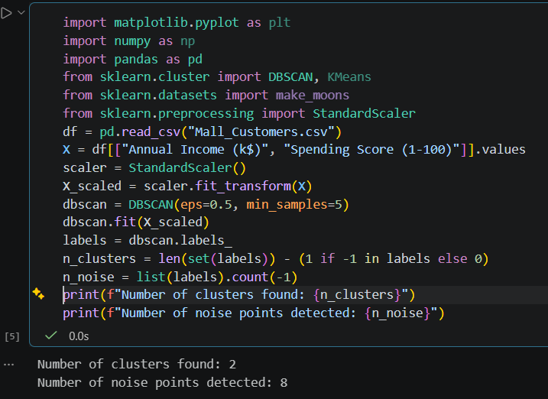
===========================================================================

- Visualize the DBSCAN clustering results from your previous task using matplotlib — plot each cluster in a different color, and mark noise points in black. Add axis labels and a legend for clarity.
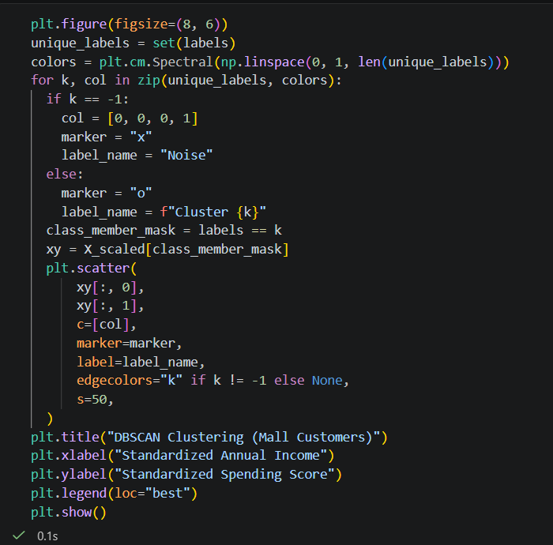

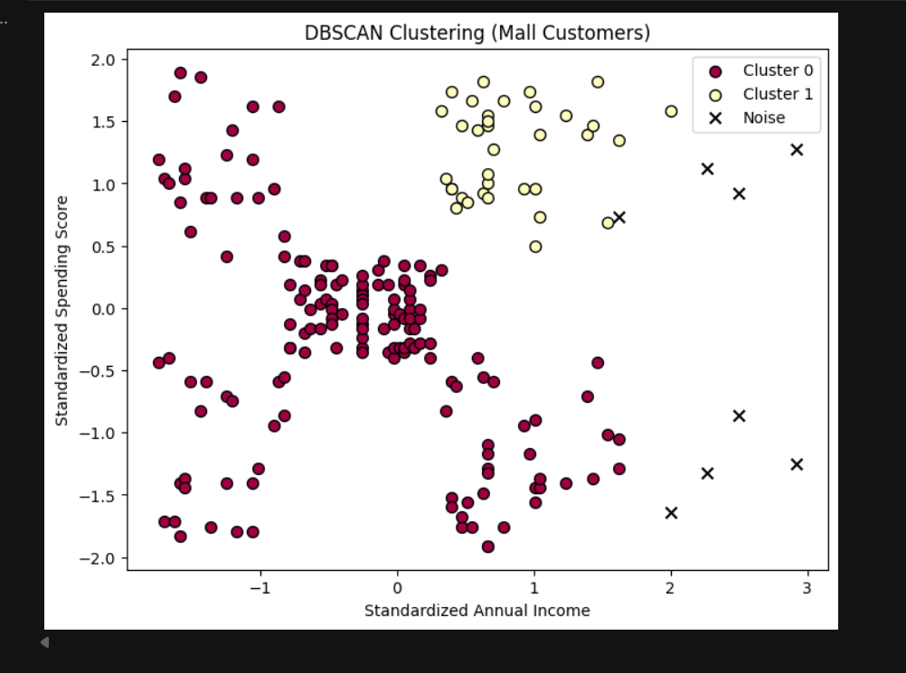

===========================================================================

- Change the DBSCAN parameters (eps and min_samples) to see how the number of clusters and noise points change. Write a short summary (3-4 lines) explaining how parameter choices affect the clustering outcome for your dataset. Try at least two different values for eps and min_samples, and compare results.
Parameter Tuning (eps and min_samples)
Let's compare two different parameter configurations:
- Configuration A (eps=0.3, min_samples=10): A smaller neighborhood radius results in stricter grouping, fewer core samples, a higher number of micro-clusters, and significantly more noise points.
- Configuration B (eps=0.8, min_samples=3): A larger radius merges distinct groups together into fewer clusters, dramatically reducing the number of noise points as outlying points get absorbed.
Summary: Tuning eps controls the neighborhood distance threshold—increasing it merges clusters and reduces noise, while decreasing it fragments clusters and increases noise. Meanwhile, min_samples sets the density threshold; higher values require denser neighborhoods to form clusters, converting sparse group points into noise.

===========================================================================

- Compare DBSCAN and K-Means on the same dataset: run both algorithms, plot their cluster assignments side by side, and briefly note which method better handles outliers or oddly-shaped clusters.Use the same features and number of clusters (for K-Means) as you observed with DBSCAN.

We run K-Means using the exact same features and set $K$ equal to the number of clusters found by DBSCAN (excluding noise) to compare side-by-side.

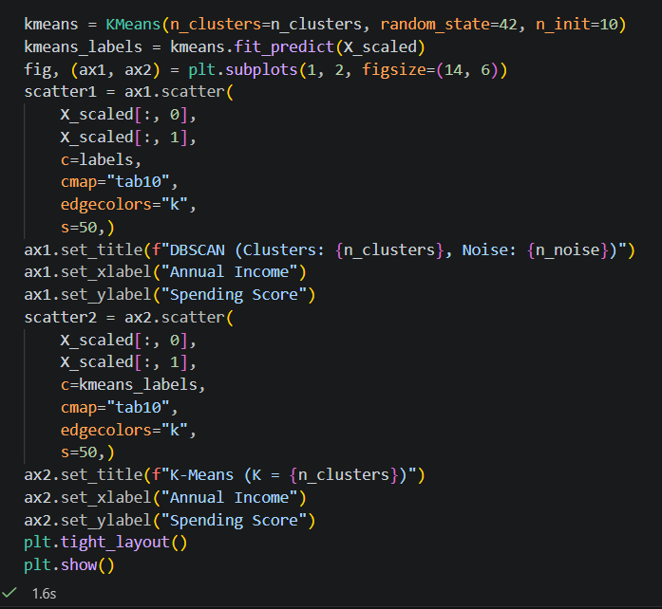

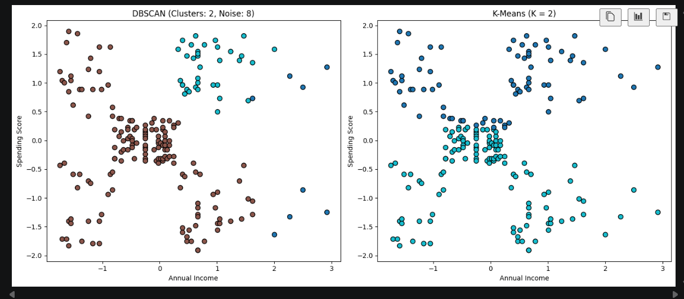

Comparison Note: DBSCAN handles outliers gracefully by labeling them as noise (-1) and can discover arbitrarily shaped clusters. K-Means, on the other hand, strictly forces every single point (including outliers) into one of the $K$ spherical clusters, which often distorts cluster boundaries.

===========================================================================

- Pick a dataset with non-spherical clusters (e.g., make_moons or make_circles from sklearn.datasets), and use DBSCAN to cluster the data. Identify and print the indices of all points labeled as noise (outliers).

